Murder Mystery Weekend

Ahh! The countryside is SO relaxing! What could be nicer than a weekend in a lovely old house, with a gathering of charming people quaffing tipples, taking the air and having delightful conversations? Well, some might say that sounds a little dull, and wouldn’t it be more thrilling if the whole event was enlivened by a nasty case of…

MURDER!!!

Hold onto your titfers when a murder mystery is created that would make Agatha Christie proud. All you have to do is make your way up the drive, with a country-house costume (upstairs or downstairs) and enthusiasm for improvisation and old-school crime drama. Led by the seasoned whodunit expert (and ace theatre practitioner) Alison Goldie, the participants will develop characters who then inhabit all the rooms of the house, in a site-specific story in which the killer is not immediately apparent. In a final denouement, the threads of the narrative will come together and ALL WILL BE REVEALED.

Creative, involving, collaborative and absolutely loads of fun – this will be a weekend you will never forget*

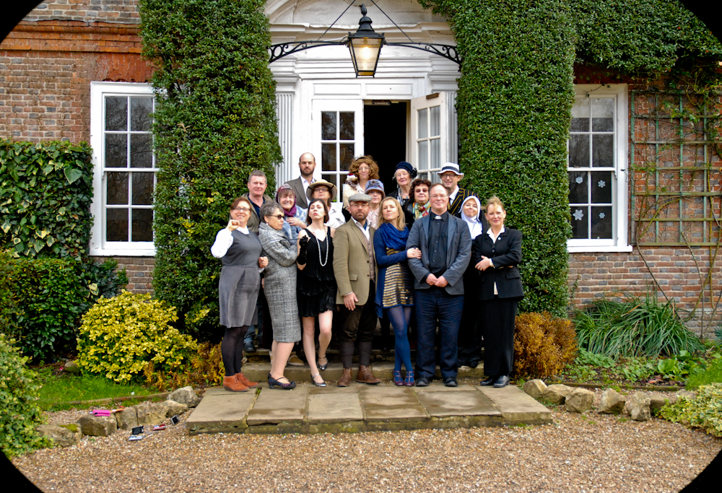
Sheer Bloody Murder, Kent

Previous participants say:

“The balance of workshop, warm-ups/getting to know each followed by the play itself was spot on. I enjoyed the weekend immensely. What a great thing to do! The whole weekend flowed smoothly and proved enormously enjoyable and highly entertaining” Angie Abingdon

"The weekend was great fun, from the murderous plots we witnessed being hatched as we roamed through the wonderful country house with all its nooks and crannies, to the dinner party hosted by the Lord of the Manor, the eventual murder and the ensuing sleuthing skills to discover who done it. Highly recommended." Carmel O’ Reilly
“The workshops were really well planned in terms of developing a character, leading to characters with remarkable depth and back story. Alison was inspired in the way that she brought such disparate threads together to devise a believable tapestry of motive and story to create a final denouement.” Karen Little
“It was amazing, thank you!” Adam Bye
“All in all a very enjoyable weekend. Total escapism. To be recommended to all. “ Alison Coates

Note: Murder Mystery can also be hired for a normal house, a hotel, or any institution, theatre or educational establishment. Cost: negotiable.

Contact Alison Goldie for more information
www.alisongoldie.com

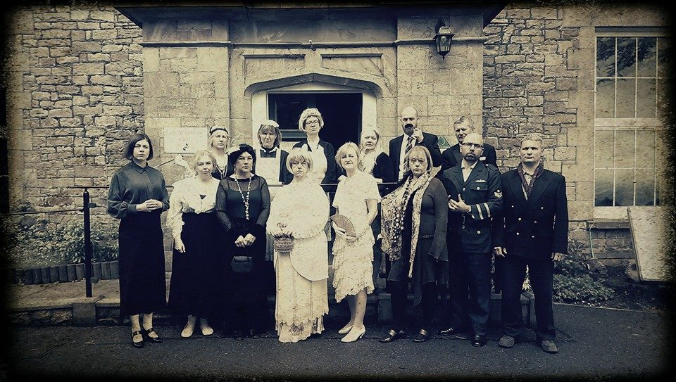
Murder in the Wilderness, Gloucestershire

*Fake blood optional

